# **Part 2 - Predictive Analytics and Visualisation of Insights**

1. **Correlation Dashboard based on Occupation and Education - Claimed amount vs Income.**

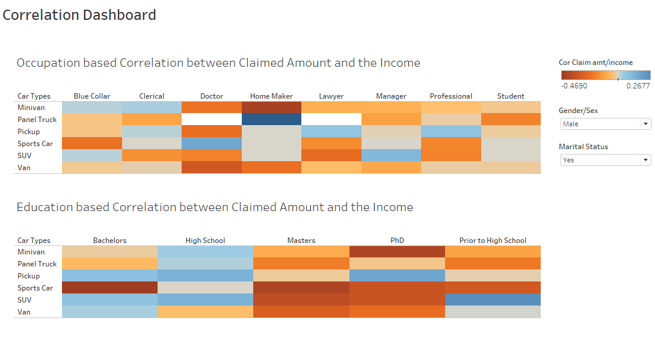

*Insight – A female manager who owns a Panel truck having the highest correlation (0.895) between the claim amount and the income. Similarly a married male Doctor who owns a sports car have the highest correlation between income and the claim amount.*

1. **Clustering dashboard based on Occupation and Education – Claim amount vs Education and Car Age vs Occupation**

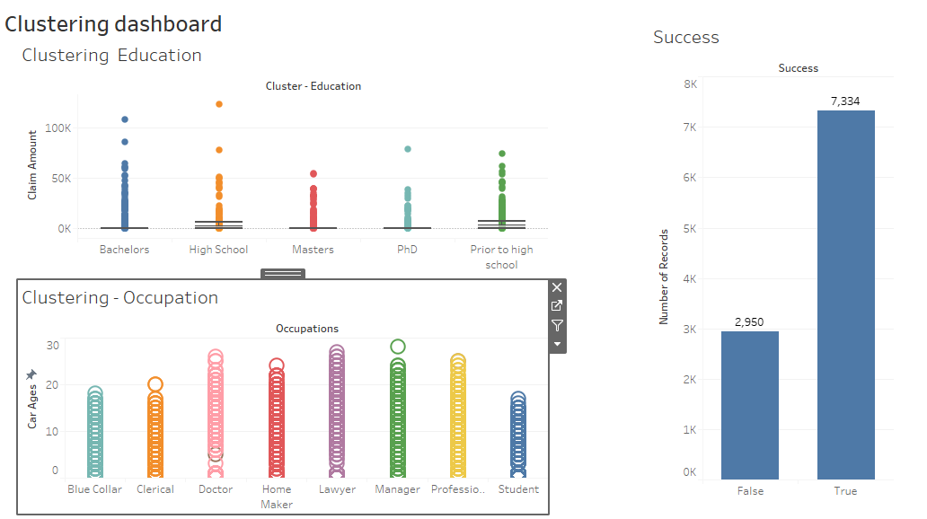

*Insight –*

*Clustering Education - The average Claim amount is 1512.16, but as we can see there is an outlier in Education- High school with a claim amount of 123.25K. Success chart shows us that out of total of 10284, our cluster estimated 7334 correctly.* ***Thus the accuracy of this cluster analysis is 71.31%.***

1. **Predicted Claim Amount & Quadrant Analysis**

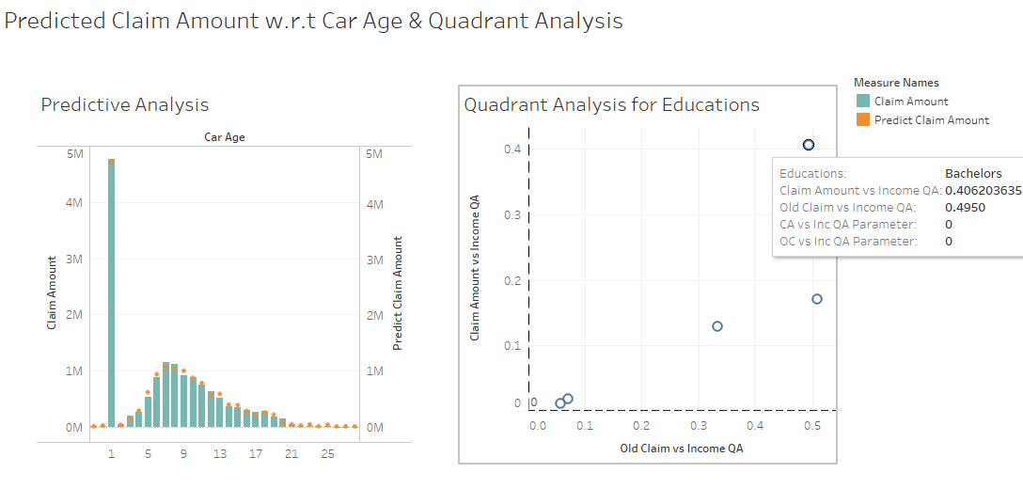

*Insight- As we can see for bachelors, the correlation between the Claim amount vs Income is 0.40 and Old Claim vs Income is 0.49 and is the highest among all the education criteria.*

1. **Claim Frequency Forecasting**

* ***With additive level, additive Trend and No Seasonality***

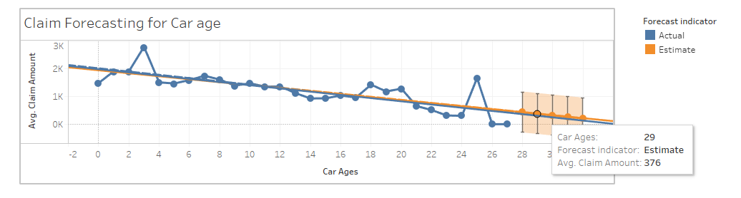

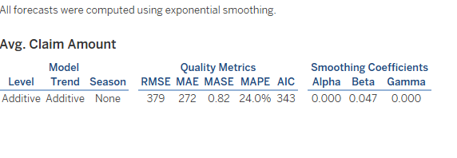

*Insight - With additive level, additive Trend and No Seasonality, the average estimated claim amount at Age 29 is 376. The MAPE (mean absolute percentage Error is 24% and AIC is 343.). Thus the accuracy is 76.0%.*

* ***With additive level, additive Trend and additive Seasonality*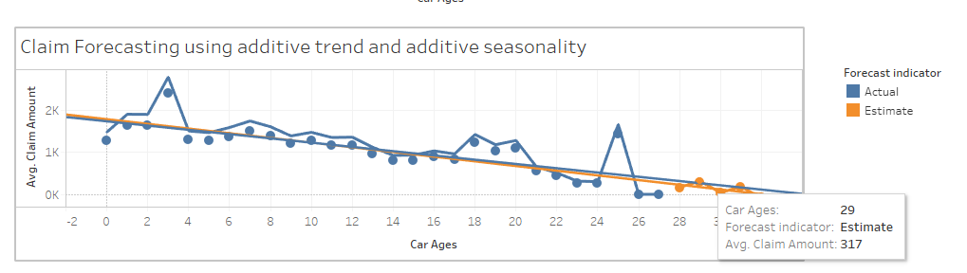**

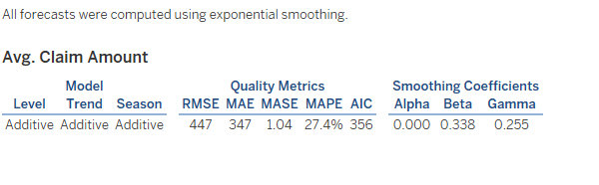

*Insight - With additive level, additive Trend and additive Seasonality, the average estimated claim amount at Age 29 is 317. The MAPE (mean absolute percentage Error is 27.4% and AIC is 356. Thus the accuracy is 72.6%.*

***Conclusion – We will consider the model with less MAPE and lower AIC value. Thus we will go for additive trend and no seasonality model which gives us the accuracy of 76%.***